# VISVESVARAYA TECHNOLOGICAL UNIVERSITY

"Jnana Sangama", Belagavi - 590018

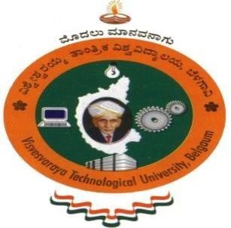

A Report on

#### Food Preservation/Packing

**NON CREDIT MANDATORY COURSE**

Submitted in partial fulfillment of the requirement for the award of the degree of

**Bachelor of Engineering in**

**Computer Science and Engineering**

**By**

**ANISH KUMAR**

**1AY21CS028**

Under the guidance of

**Mrs. VARALAKSHMI B D**

**Assistant Professor**

**Department of Computer Science and Engineering**

**DEPARTMENT OF COMPUTER SCIENCE AND ENGINEERING**

**ACHARYA INSTITUTE OF TECHNOLOGY**

(Affiliated to Visvesvaraya Technological University, Belagavi) 2024-2025

 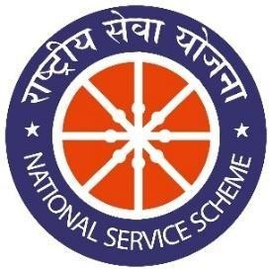



*OF PARTICIPATION*

This is to certify that Mr. Anish Kumar has successfully participated in the activity **Food Preservation/Packing** which was conducted on **22/02/2024** as a part of AICTE activity from the Department of CSE, AIT.

Signature of Department Coordinators

1. Prof.Varalakshmi B D
2. Prof. Bhavyashree S P

ACKNOWLEDGEMENT

The satisfaction that accompanies the successful completion of this AICTE activity point program would be incomplete without the mention of the people who made it possible through constant guidance and encouragement.

I would like to take this opportunity to express my heart-felt gratitude to Dr. C.K Marigowda, Principal Acharya Institute of Technology, for providing the necessary support to complete this activity.

I would like to thank Prof. Rajeev Bilagi, HOD, Department of Computer Science and Engineering, for his valuable support.

I wish to express my deepest gratitude and thanks to Mrs. Varalakshmi B D and Mrs. Bhavyashree S P, Assistant Professor Department of CSE, for their suggestions during this activity.

A warm thanks to all the faculties of the Department of Computer Science and Engineering, who have helped me with their views.